TASK 3: Pandas Data Analysis

Student Details
Name: G HARINI
Course: B.Tech - Computer Science and Engineering
Domain: Python Developer Intern

Aim
The aim of this task is to perform data analysis using Python Pandas library. It involves loading structured data from a CSV file, cleaning the dataset, applying filtering and grouping operations, and generating meaningful insights from student performance data.

Tools Used
Python 3.x
VS Code (Code Editor)
Pandas Library
CSV File (student_data.csv)

Procedure
- Created a CSV file named student_data.csv containing student details.
- Imported Pandas library in Python script.
- Loaded the CSV file using pd.read_csv().
- Converted Marks column into numeric format and removed invalid values.
- Displayed the complete dataset.
- Filtered students who scored above 80 marks.
- Calculated average marks for each department using groupby().
- Identified top performer and lowest performer.
- Calculated overall average marks of all students.
- Displayed final insights in a structured format.

Dataset (student_data.csv)
Name,Department,Marks
Harini,CSE,85
Rahul,CSE,78
Anu,ECE,90
Kiran,EEE,67
Priya,CSE,92
Vamsi,ECE,88
Sai,EEE,73
Meena,CSE,95

Code
import pandas as pd

# Load CSV file
data = pd.read_csv("student_data.csv")

# Convert Marks to numeric and clean invalid values
data["Marks"] = pd.to_numeric(data["Marks"], errors="coerce")
data = data.dropna()
data["Marks"] = data["Marks"].astype(int)

# Display full dataset
print("\nSTUDENT DATA\n")
print(data)

# Filter students with marks > 80
high_marks = data[data["Marks"] > 80]
print("\nSTUDENTS WITH MARKS ABOVE 80\n")
print(high_marks)

# Average marks by department
avg_marks = data.groupby("Department")["Marks"].mean()
print("\nAVERAGE MARKS BY DEPARTMENT\n")
print(avg_marks)
print("\nFINAL INSIGHTS\n")

# Top performer
top_student = data.loc[data["Marks"].idxmax()]
print(f"1. Top Performer: {top_student['Name']} with {top_student['Marks']} marks")

# Lowest performer
low_student = data.loc[data["Marks"].idxmin()]
print(f"2. Lowest Performer: {low_student['Name']} with {low_student['Marks']} marks")

# Best department
best_dept = avg_marks.idxmax()
print(f"3. Best Performing Department: {best_dept} with average {avg_marks.max():.2f} marks")

# Overall average
print(f"4. Overall Average Marks: {data['Marks'].mean():.2f}")

Screenshots: (Code)

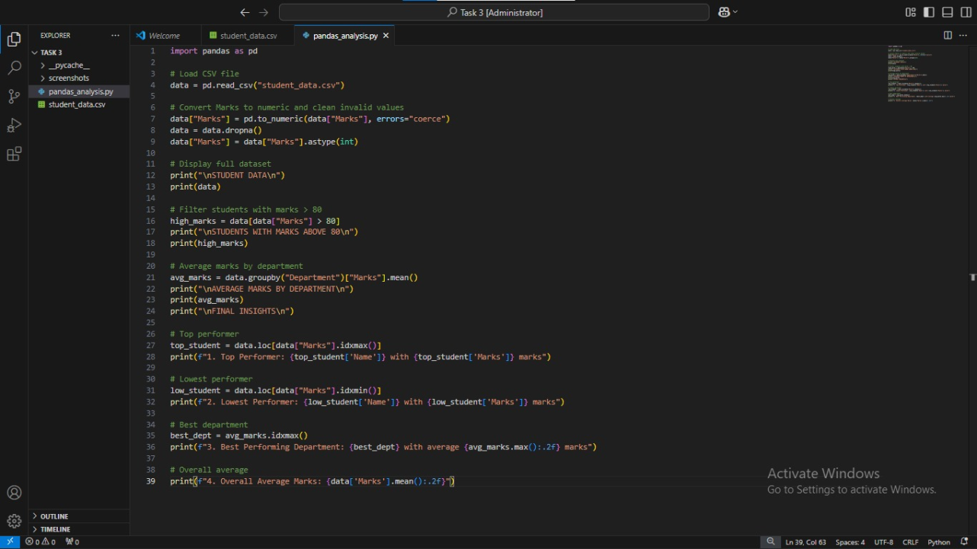

(Output)
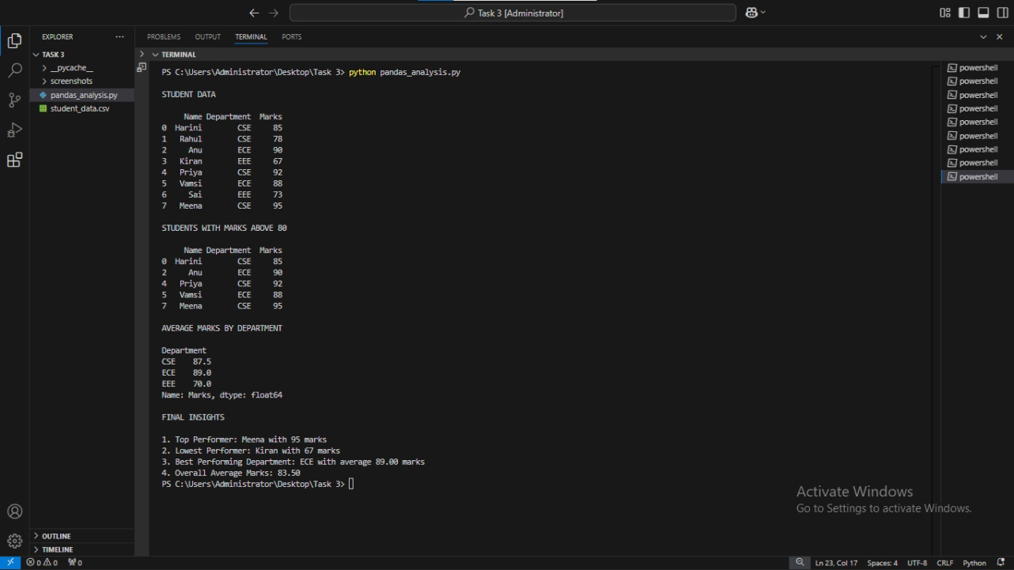

(System proof)
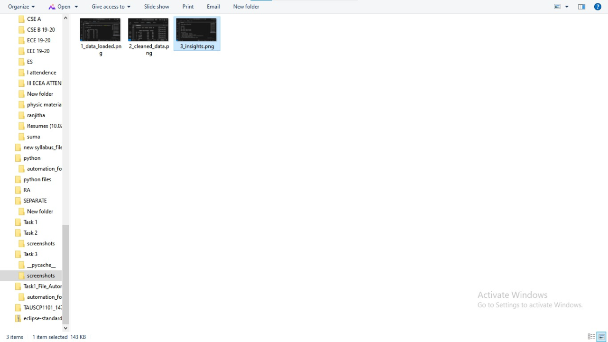
(Folder Structure)
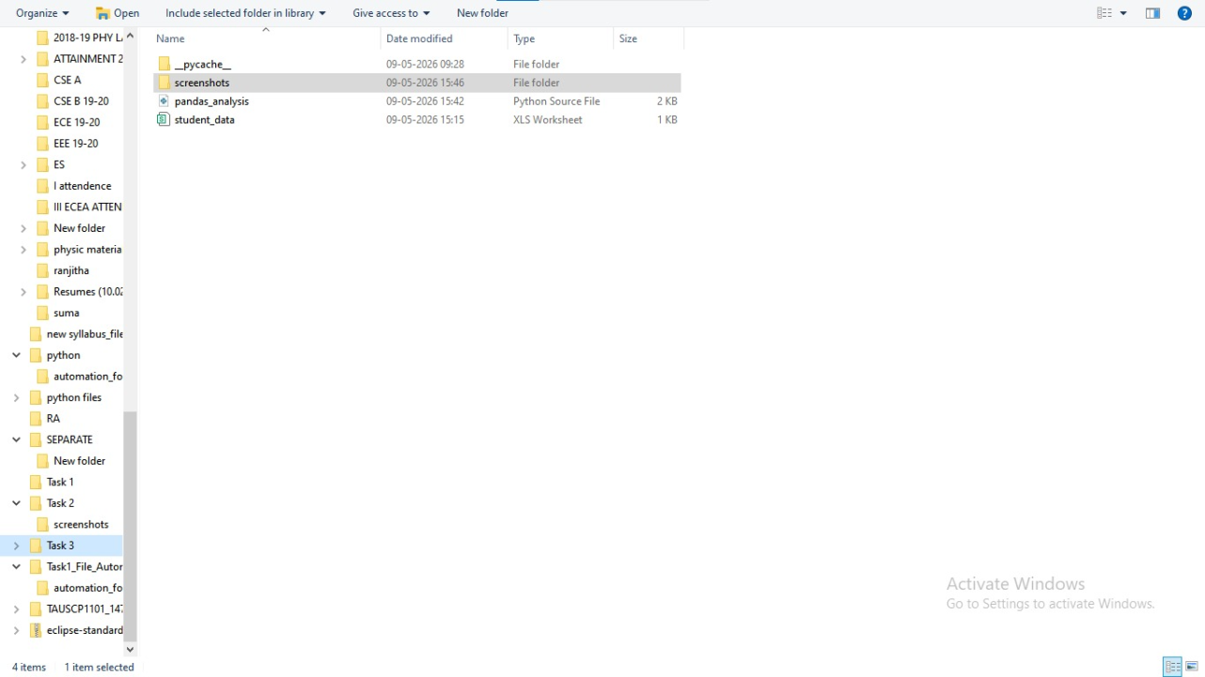

GitHub Link: https://github.com/HariniG4107/python-internship-tasks.git
Conclusion
This task demonstrated the use of Python Pandas library for data analysis. It helped in understanding data cleaning, filtering, grouping, and insight generation.

